AI in E-commerce

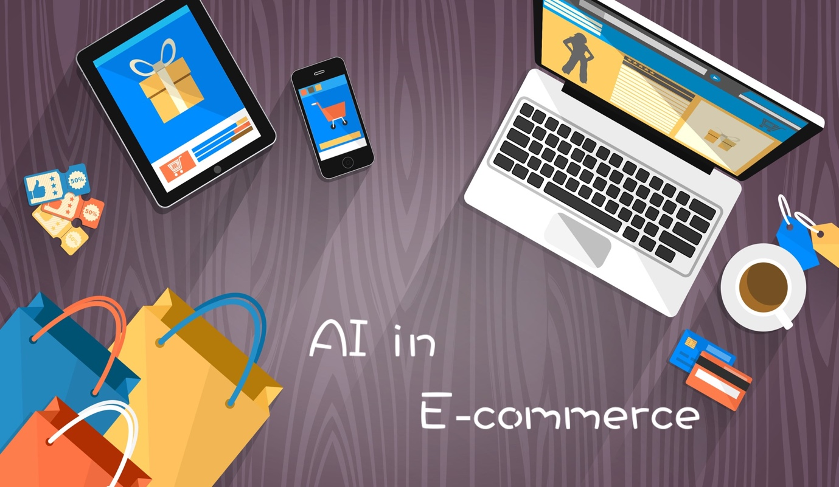

*Group C9*

*Dinuka Nanayakkara,*

*Sonal Sandeepa,*

*Dilshan Viduranga,*

*Ravindu Sulakshana,*

*Kavindu Dilshan,*

*K.M.Igalavithana,*

*Savidhya Karunathilake,*

*M.S.I.Peiris,*

*M.G.S.R.S.Udayakantha,*

*Vinuka Kodituwakku*

Table of Contents

A basic introduction to Artificial Intelligence 2

History of AI 2

Types of AI 2

Applications of AI 2

Problems in traditional e-commerce without Artificial Intelligence 3

Limited personalization 3

Inefficient search 3

Manual Categorization 3

Ineffective recommendations 3

How can Artificial Intelligence solve these problems? 3

Personalized recommendations 3

Natural Language processing 4

Image recognition 4

Automated categorization 4

Theoretical and practical aspects of AI for e-commerce 4

Additional assumptions 5

Workload matrix 7

# A basic introduction to Artificial Intelligence

Computer systems' simulation of human intelligence is called artificial intelligence or AI. It entails the creation of algorithms that can carry out operations like learning, problem-solving, and decision-making, which generally need human intellect. One of the most revolutionary technologies of the twenty-first century, AI offers a wide range of possible uses. This part will give a general overview of AI, covering its background, subfields, and uses.

## History of AI

The first attempts to create machines that could think and learn like humans were made by computer scientists in the 1950s, which is when the idea of AI initially emerged. John McCarthy, a computer scientist usually credited as being the pioneer of artificial intelligence, first used the term "artificial intelligence" in 1956. Since then, there have been several advances in AI, including the creation of deep learning, neural networks, and machine learning algorithms.

## Types of AI

There are three primary categories of artificial intelligence: super AI, broad AI, and narrow or weak AI. Narrow or weak AI is made to handle tasks, such as image recognition or language processing. On the other hand, a general or powerful AI can carry out any intellectual task that a person can. A possible future AI called Super AI, commonly referred to as artificial general intelligence, would outperform human intelligence in every area.

## Applications of AI

AI has several uses in many different areas, including e-commerce. AI is applied in e-commerce to enhance the consumer experience, boost sales, and streamline processes. Personalized suggestions are one of the biggest uses of AI in e-commerce. To make recommendations for products that are most likely to be of interest to the user, AI algorithms analyze customer data, including browsing and purchase history.

Chatbots are another way that AI is used in e-commerce. Chatbots are virtual assistants that use AI and can communicate with users in natural language. They can assist clients with purchases, respond to inquiries, and make product recommendations. There is less need for human customer service personnel because chatbots can handle many client inquiries at once.

As a result, AI has become one of the most revolutionary tools of the twenty-first century. Its numerous possible uses exist, and it has had a sizable effect on the e-commerce sector. Businesses can enhance the customer experience, boost sales, and streamline processes by utilizing AI-powered solutions. We can anticipate even more cutting-edge uses for AI as it develops in the e-commerce sector and elsewhere.

# Problems in traditional e-commerce without Artificial Intelligence

Online shopping platforms based on predetermined guidelines and models are a part of traditional e-commerce. Customers use these platforms to peruse product catalogs and make purchases by going through a series of predetermined steps. Traditional e-commerce platforms, however, have several drawbacks that can harm client experiences and company operations. In this part, we'll talk about some of the issues with conventional e-commerce and how AI can help.

## Limited personalization

Personalization options are scarce on traditional e-commerce sites. Customers frequently receive a generic selection of offers, promos, and suggestions. Customers may not find what they are looking for or may be presented with irrelevant goods, which can result in a bad customer experience. Additionally, this may lead to a decline in client loyalty and lost sales.

## Inefficient search

Traditional e-commerce platforms frequently depend on imprecise and inefficient keyword-based searches. Even though the products are available on the platform, customers might not be able to discover what they are looking for. Customers may become angry, and sales may be lost consequently.

## Manual Categorization

The manual categorization of goods used by traditional e-commerce platforms can be time-consuming and error-prone. This may result in incorrect or incomplete product categorization, which could harm client satisfaction and reduce sales.

## Ineffective recommendations

Simple recommendation systems that are based on previous transactions or browsing history are frequently used by traditional e-commerce platforms. These systems might not account for extraneous elements like client tastes or outside elements like the weather or events. Ineffective recommendations could result from this, which would decrease client loyalty and result in lost sales.

# How can Artificial Intelligence solve these problems?

AI can solve these issues by offering individualized and effective remedies. Here are a few methods that AI can enhance established e-commerce platforms:

## Personalized recommendations

Customer information, including browsing and purchasing history, can be analyzed by AI algorithms to produce tailored suggestions. These suggestions may be based on client preferences, outside variables, and other elements that may affect clients' purchasing choices.

## Natural Language processing

Artificial intelligence-powered chatbots can communicate with customers in natural language while making suggestions that are specific to them and answering their questions. This can enhance customer satisfaction while lightening the load on customer support agents.

## Image recognition

Using images to look for products, AI-powered image recognition can enhance search capabilities. This can be especially helpful in sectors like fashion and house furnishings.

## Automated categorization

Automating product categorization with AI-powered algorithms can reduce errors and enhance the consumer experience. The ability to more precisely categorize products can also enhance search capabilities.

The customer experience and company operations can be negatively impacted by the limitations of traditional e-commerce platforms. AI, on the other hand, can solve these issues by offering effective and individualized remedies. Businesses can boost sales, enhance customer experiences, and streamline processes by utilizing AI-powered technologies. We can anticipate even more creative answers to the issues in conventional e-commerce as AI develops.

# Theoretical and practical aspects of AI for e-commerce

By offering solutions to the various problems that conventional e-commerce has to deal with, artificial intelligence (AI) is revolutionizing the e-commerce sector. AI is being used by e-commerce businesses in a variety of ways, from enhancing supply chain management to personalizing customer encounters. With appropriate examples, we will address both theoretical and practical facets of AI in e-commerce in this section.

The capacity to give customers a personalized experience is one of the most important advantages of AI in e-commerce. Personalization is essential for fostering client loyalty and boosting revenue. To make personalized suggestions and offers, AI algorithms can examine customer information like purchase history, search terms, and browsing habits. For instance, Amazon makes product recommendations to consumers based on their past purchases and search terms. Customers are therefore more likely to discover goods that suit their interests, which boosts customer satisfaction and encourages repeat business.

Increasing supply chain management is another useful use of AI in e-commerce. For e-commerce businesses, supply chain management is a crucial component, and AI can aid to optimize this process. To forecast product demand, AI algorithms can examine past sales data, weather trends, and other variables. Utilizing this data will improve inventory control, cut waste, and guarantee that goods are available when consumers need them. Alibaba, for instance, makes use of AI to streamline waste reduction and inventory administration. The business uses AI algorithms to evaluate historical sales data to forecast demand, which aids in inventory level optimization and waste reduction.

By supplying chatbots that can respond to customer questions and offer support, AI can also assist e-commerce businesses in improving customer service. Chatbots are AI-powered virtual aides that can respond right away to inquiries and complaints from clients. Without the use of human operators, this technology can assist e-commerce businesses in providing customers with round-the-clock assistance. For instance, Sephora employs chatbots to assist customers in finding products and responding to their questions.

AI is being used in theoretical facets of e-commerce, such as search engine optimization (SEO) and fraud detection, in addition to these practical uses. The practice of optimizing a webpage for search engines is known as SEO. Search engine data can be analyzed by AI systems, and websites can be optimized to appear higher in search results. Similar to human analysts, AI systems can examine transaction data and spot fraud. For instance, PayPal employs AI to identify fraudulent transactions and stop losses.

In conclusion, AI is revolutionizing the e-commerce sector by addressing several issues that conventional e-commerce has. AI is completely changing how e-commerce businesses run, from personalized encounters to supply chain optimization. Future applications of AI in e-commerce are likely to be even more creative as long as technology keeps progressing.

# Additional assumptions

Although there have been substantial improvements in the field thanks to the use of artificial intelligence (AI) in e-commerce, there are still some difficulties. We will talk about some additional presumptions that can affect AI in e-commerce and how they can affect the effectiveness of the technology in this part.

The type and volume of data that is readily accessible is one of the key presumptions that can influence AI in e-commerce. To learn and make predictions, AI needs a lot of data, and incomplete or biased data can produce unreliable findings. For instance, an e-commerce site may not be able to accurately anticipate the behavior of customers outside of that group if it only has data on customers from a particular geographic area or demographic.

The degree of market competition is a different presumption that may influence AI in e-commerce. The competition for talent and resources grows as more businesses integrate AI into their e-commerce platforms, which can lead to higher costs and a diminished capacity for innovation. Additionally, it might be necessary to invest in AI skills to keep up if a company's rivals are using it to their advantage.

The possibility for ethical issues to emerge is one potential difficulty with AI in e-commerce. An AI algorithm may unintentionally discriminate against specific groups of people, for instance, if it is used to determine pricing or product suggestions. This might damage a company's image and result in accusations of bias. Before being implemented in a live environment, AI algorithms must be fully tested and validated to reduce this risk.

The regulatory climate in which a company conducts business is another presumption that may have an impact on AI in e-commerce. As more nations enact legislation governing the use of AI, it may raise entry barriers and the expense of compliance. For instance, the General Data Protection Regulation (GDPR) of the European Union places stringent restrictions on the gathering and processing of personal data, which may make it more challenging to apply some AI algorithms.

Lastly, it's critical to think about how AI might affect employment in the e-commerce sector. Even though AI can automate a variety of tasks, it also offers new chances for employees to build and maintain AI systems. But as AI develops, it's critical to make sure that employees are properly prepared to fill these positions and that they do not fall behind.

In summary, AI can completely transform the e-commerce sector, but it is not without its difficulties. The assumptions and potential effects outlined in this section must be taken into account to guarantee that AI is utilized successfully in e-commerce. By doing this, organizations can implement AI strategically and profit from this potent technology.

# Workload matrix

|  |  |  |
| --- | --- | --- |
| 27223 | Dinuka Nanayakkara | * Helped with the presentation. * Created the speech to the topic. * Presented |
| 28773 | Sonal Sandeepa | * Helped with the presentation * Created the speech to the topic * Presented |
| 28527 | Dilshan Viduranga | * Helped with the poster * Created the speech to the topic * Presented |
| 29243 | Ravindu Sulakshana | * Helped with the poster * Created the speech to the topic * Presented |
| 29295 | K.M.Igalavithana | * Helped with the poster * Created the speech * Presented |
| 27245 | Savidhya Karunathilake | * Helped with the report * Created the speech to the topic * Presented |
| 27242 | M.S.I.Peiris | * Edited the video * Created the speech to the topic * Presented |
| 29024 | M.G.S.R.S.Udayakantha | * Helped with the report * Created the speech to the topic * Presented |
| 27298 | Vinuka Kodituwakku | * Helped with the report * Created the speech to the topic * Presented |